Conduct data triangulation and analysis (including data mining as appropriate) of all available data and evidence from NHWA, HLMA reports and published literature on the health workforce covering the following areas:
  - Review of a 10-year trends in the stock and density of health workers in the Region and per country (an analysis of data in NHWA v2 – data currently available with some gaps) – disaggregate by country types: HIC, LMIC, East, Southern Africa, West Africa and Central Africa; WHO SSL 2023; by cadres

UHC = years 2000, 2005, 2010, 2015, 2017, 2019, 2021 projection to 2022, 2023
Human development index= global and sub-saharan Africa
GDP per capita
% of the national budget allocated to health
Household expenditure on health
Life expectancy
HALE
Disparity between Life expectancy and HALE
Maternal mortality ratio = 2000 – 2017, then 2018 – 2022 projected
CDR or Disability-adjusted life years (DALYs)

  - Training and Education capacities in the Region (Update from the previous report – for countries, there is new data on the training capacity of 2022)
  - Overview of the Labour flows (inflows and out-flows), including migration – synthesis from HLMA reports – 13 countries.
  - Health workforce (un)employment (from 1st edition of State of HWF report and 13 HLMA reports – quantify annual employment of HWs and number of unemployed HWs by cadre)
  - Synthesis of projected supply, demand and need for health workers (to be integrated with other ongoing work).
  - Integrate analysis on health workforce spending and budget space (use paper by Pascal et al 2023 + projection from AFRO model).
  - State of health workforce governance and stewardship/leadership (use dataset collected in NHWA v2 AFRO + from 1st edition of State of HWF report)
  - Explore reasons for the observed trends and the impact of HWF on health and socio-economic indicators.
  - Assessment of key performance indicators compared to targets/thresholds (to be finalised after the main analysis).
  - Recommended actions for the next of half of the SDG era, 2025 – 2030.

Explanatories

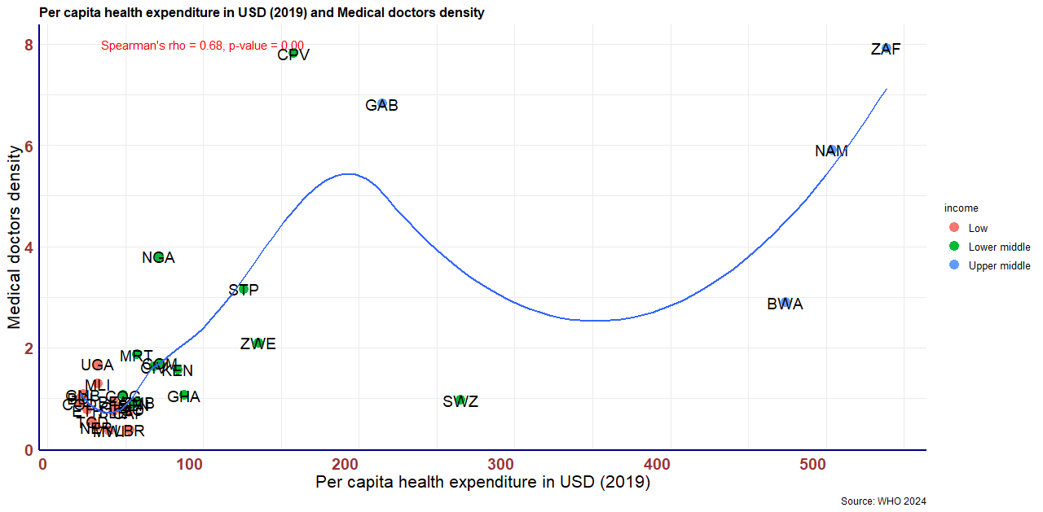

Impacts
